**NURS 316: Nursing Care Plan for a Hospitalized Child**

**Frances Payne Bolton School of Nursing**

**Case Western Reserve University**

**Student**: Jamie Lee **Faculty:** Laura Blankschaen

**Date of Care**: 9/29 **Clinical Setting**: Metro 4C

**Informant and other sources of data:** EPIC and Patient

***Part 1: Demographics***

**Child’s Initials**: CR **Age**: 25 months

**Medical diagnosis:** Skull lesion

**Sex:** M **Allergies**: erythromycin

***Part 2: Growth Measurements***

**Weight** 16 kg >97%ile **Length/Height** 90cm 74%ile

**Head Circumference** 50cm 95%ile

**BMI** 19.8 99%ile *choose one*: underweight *or* normal *or* **overweight**

**Stage of pubertal growth** Stage 1

***Part 3: Family Background***

**Three-generation family history genogram** *Include patient, siblings, parents, grandparents. See page 52 in textbook.*

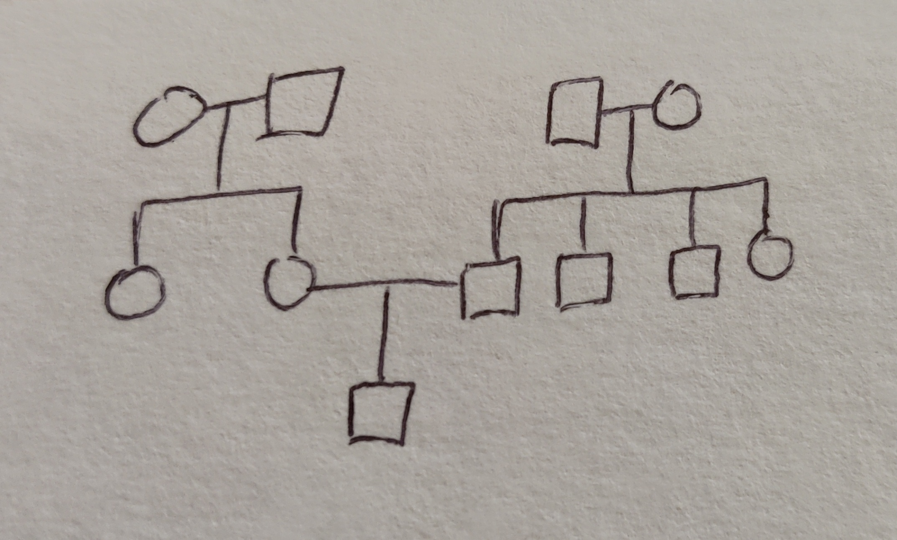Family history of childhood epilepsy; genetic screening results pending.

**Family Dynamics:** *Include data about roles, occupation, education, home and community environment, cultural and religious traditions, and family functioning. See page 31 in our text.*

*Observation of parent/child interaction:*

*x Appropriate*

*__ Not appropriate (explain)*

*Environmental Risks- check if assessed:*

*__ lead risk __ housing inadequate*

*__ alcohol use in house __ drug use in house*

*__ smokers in house __ TB exposure*

*__ guns in house __ domestic violence*

***Part 4: Fluid Balance and Nutrition***

**Maintenance fluid requirement** (*based on 100/50/20 rule*)

| Expected | Actual | Evaluation | Action |
| --- | --- | --- | --- |
| 1296 ml/day  54 ml/hr | PO: 0 ml  IV: 0 ml  Other: 0 ml  Total: 0 ml  0 ml/past 24 hours  0 ml/hr | Patient was NPO due to scheduled MRI scan. | Patient will drink water and fluids as usual post MRI scan. |

**Minimum urine output**

| Expected | Actual | Evaluation | Action |
| --- | --- | --- | --- |
| 384 ml/day  16 ml/hr | Urine: 30 ml  Stool: 0  Emesis:0  Other:0  Total: 30 ml  30 ml of urine/past 24 hours  1.25 ml/hr | Patient was NPO due to scheduled MRI scan. | Patient will return to drinking fluids as usual post MRI scan, which will bring output back to normal. |

**Diet/formula as ordered** (type, amount, and frequency): NPO

**Significant nutrition history**: N/A

**Daily caloric requirement for this child:** 1000 Kcals/day

**Nutritional concerns and nursing interventions** - No concerns except for maybe the child’s weight (might advise dietary consult but since the child is quite young, it isn’t pertinent).

***Part 5: Vital Signs***

| Expected range for age | Actual | Evaluation | Action |
| --- | --- | --- | --- |
| Temp: 97.4-99.6F  Pulse: 70-120 bpm  Resp: 20-30  BP: 90-110/55-75 mmHg  Pain assessment tool: 0 | Temp: 98.4F  Pulse: 116  Resp: 21  BP: 97/65  Pain score: 0 | This is within the normal range of vital signs. | None |

***Part 6: Developmental Level of Patient***

**Developmental Level for Child’s Chronological Age:**

| Expected | Expected  (Description of Stage) | Actual  (Observed behaviors) | Evaluation |
| --- | --- | --- | --- |
| Erikson’s stage: __________________ | (Autonomy vs Shame & Doubt)  Develop a greater sense for self-control | (Autonomy vs Shame & Doubt)  Lifted his arm up for me when I was taking his blood pressure. | Patient is within expected stages of development. |
| Piaget’s stage: __________________ | (Preoperational)  Begin symbolic play and learn to manipulate symbols | (Preoperational)  Was playing with his toy football and passing it between hands. | Patient is within expected stage of development. |
| Milestones | Shows more and more independence  Speaks in 2-4 word sentences.  Follows simple instructions.  Walks steadily. | Follows simple instructions. Walks steadily.  Shows more and more independence. | CR did not speak too much, he was quite non-verbal. |

*At what age did your child? Ask questions that are appropriate to child’s age*

*Sit alone -* 7 months *Walk alone -* 13 months *Feed self -* 23 months

*Talk (2-3 word sentences) -* currently doing

*Dress self -* N/A

*Toilet trained: Day______ Night______* (not fully achieved; still wearing diapers)

*School problems: _N/A_ reading, writing _N/A__ behavior __N/A__ special needs*

*Are there any behavior problems at home? Please describe:* None  
 None

*Mental health concerns? Please explain:* history of epilepsy.

*Ability to form/maintain peer relationships:* N/A

*Activities or sports involvement:* N/A

*Dating/sexual activity:* N/A

**Age-specific care considerations:**

*Choose 3 topics from this list as they pertain to your patient: anticipatory guidance, preparation for procedures, comfort measures, play, communication techniques, safety, or impact of hospitalization.*

Patient may need to be potty trained very soon; patient is still using diapers when he should probably be potty trained by 25 months.

Patient’s focal epilepsy should be managed properly and compliant to plan of care.

Patient should be talking with basic 2-4 word sentences; he is quite nonverbal.

***Part 7: Health Alteration***

**Current Primary Medical Diagnosis**: Skull Lesion.

**History of present illness**: Focal epilepsy (positive PRRT2 gene mutation); controlled on Trilepta

**Review of hospital course including surgical history:**@ 23 weeks - admitted to the ED (1/27/2020) with BRUE (Final diagnosis - focal seizures)

2/1/2021 Follow up and genetic epilepsy panel done - pending  
9/2/2020 Presented to ED again due to fever of 100.8F.

Divot on L temporal skull w/ skull x-ray findings with lucent cyst like lesion in frontal lobe  
Concerns for Langerhans Cell Histiocytosis - trying to rule it out.

**Pathophysiology and clinical manifestations of diagnosis/disorder**:  
  
**\*\* Since he is getting his skull lesion tested in order to rule out Langerhans Cell Histiocytosis, I will write about focal epilepsy \*\***

*Medical Diagnosis:* Focal epilepsy

*Pathophysiology:* Partial (focal) seizures occur when abnormal electrical disturbances in the brain remain in a limited area of the brain. It is the most common type of seizure in people 1 year old or older.

*Signs & Symptoms:* Abnormal muscle contractions, staring spells, flushed face, dilated pupils, rapid heart rate/pulse, eyes moving from side to side.

*Diagnostic evaluation/differential diagnosis:* EEG (electroencephalogram) to check electrical activity in the brain; blood tests to check for other health problems that may be causing the seizures; head CT or MRI to find cause and location of problem in the brain.

*Causes:* Epilepsy

*Management/Treatment:* Medication, lifestyle changes for adults and children, sometimes surgery.

*Complications:* May have developmental delays; worst case: permanent brain damage.

*Prevention (if applicable):*

**Laboratory and diagnostic tests:**

| Test | Rationale for test | Results | Expected Normal Range | Implications of results for patient |
| --- | --- | --- | --- | --- |
| MRI w/out contrast following sedation | imaging for benign and malignant skull lesion; locations | being reviewed | no abnormal spots | depending on result may be able to find what is causing the skull lesion; if it’s benign or malignant; or if its Langerhans Cell Histiocytosis |
| CXR & skeletal survey | possible lytic lesions | negative | N/A | one less thing indicative of Langerhans Cell Histiocytosis |
| CBC | routine blood work | WBC 8.3  RBC 4.58  Hemoglobin 12.5  Hematocrit 34.9  Platelet 277k MPV 6.2 | WBC 6.0-17.0 RBC 3.8-5.2 Hemoglobin 10.5-14.5  Hematocrit 32-42  Platelet 250k-450k  MPV 8-12 | Smaller than average platelets (might mean that bone marrow isn’t producing enough new ones) |

*If there are none for this patient then include tests which are typically significant for this health alteration.*

**Assessment by Systems:** *record only abnormal findings otherwise simply write WNL*

| ***N= normal Ab=abnormal (Check appropriate box)*** | ***N*** | ***Ab*** |
| --- | --- | --- |
| 1. ***General appearance:*** | *WNL* |  |
| 1. ***Skin:*** *color, birthmarks, jaundice, rash, acne* | *WNL* |  |
| 1. ***Head:*** *shape, scalp, hair, AF size, PF size, sutures* |  | *skull lesion on left temporal skull* |
| 1. ***Eyes:*** *EOM, PERRLA, lids* | *WNL* |  |
| 1. ***Ears:*** *pinna, canals, responds to loud sound* | *WNL* |  |
| 1. ***Nose:*** *patency, drainage, flaring nares* | *WNL* |  |
| 1. ***Mouth:*** *gums, tongue, palate, mucosa, occlusion, throat, teeth/caries* | *WNL* |  |
| 1. ***Neck:*** *position, ROM* | *WNL* |  |
| 1. ***Chest:***   ***Female- Breasts Tanner Stage: N/A*** | *WNL* |  |
| 1. ***CV:*** *rate, rhythm, S1, S2, murmur, femoral/pedal pulses* | *WNL* |  |
| 1. ***Abd:*** *contour, umbilicus, bowel sounds, anus patent* | *WNL* |  |
| 1. ***GU:*** *Tanner stage: Stage 1* | *WNL* |  |
| 1. ***MS:*** *ROM, spine, gait* | *WNL* |  |
| 1. ***Neuro:*** *jitteriness, head control, posture, tone, Moro, suck, rooting, grasp, motor strength, sensory, coordination* | *WNL* |  |

*Document abnormals (by number): 3 (skull lesion on left temporal skull)*

**Current Medications:** *Include all meds that are administered while you are providing care, including prn meds. Medications which are affecting the child during your time of care should also be included.*

| Medication order (drug, dose, route, frequency) | Safe dose recommendation (mg/kg/dose) | Safe dose calculation (Based on weight is prescribed dose safe?) | Drug Class  **&**  Reason child is receiving medication | Side effects (major ones only) | Nursing considerations |
| --- | --- | --- | --- | --- | --- |
| levetiracetam (Keppra) 100 mg/mL oral solution twice daily | 160mg/kg/dose | Yes | Anticonvulsant; focal epilepsy | aggression, anxiety, rapid breathing, irregular heartbeat | Observe for adverse effects.  Assess and document any signs of seizure activity. |
| oxycarbazepine (Trileptal) 300mg/5mL oral suspension twice daily | maximum 960mg | Yes | Anticonvulsant;  focal epilepsy | Agitation, confusion, bleeding on lips, rectal bleeding | Monitor kidney and liver function.  Observe for adverse effects.  Assess and document any signs of seizure activity. |
| dextrose 5% and NaCl 0/9% w/ KCL 20mE1 1000mL IV | 54mL/hr | Yes | NPO; fluid and nutrition maintenance | slow heartbeat, change in thinking, allergic reaction, chest pain | DO NOT administer IV push or undiluted; may cause cardiac arrest |
| lidocaine 4% cream | N/A | N/A | Local Anesthetic | cyanosis, dark urine, dizziness, tachycardia, confusion | Assess IV site before applying cream |

*If an ordered medication is outside the recommended range explain rationale here. _____________________*

**Nursing Diagnoses and Care Plan**

*Address 2 nursing diagnoses. At least one diagnosis must be psychosocial and at least one diagnosis must be physiologic. Diagnosis may apply to child or family. Standardized pediatric care plans are available as resource.*

| Nursing Diagnosis | Expected Outcome  (Be specific with individualized and measurable goals) | Nursing Interventions  (These start with an action verb) | Evaluation  (Was goal met? Why or why not?) |
| --- | --- | --- | --- |
| Example: Risk for fluid volume deficient R/T decreased po intake & fluid losses through fever | Child will receive 57 mL/hour of fluids via po or IV route. | Educate …  Provide popsicle…  Weigh child BID  Assess…. | Child was unwilling to drink despite offer of favorite fluids. IV fluids were begun … |
| 1  Risk for trauma or suffocation related to focal epilepsy | Child will receive his daily Keppra and Trileptal to manage focal epilepsy.  Patient’s parents will modify environment as needed to enhance safety.  Patient’s parents will maintain treatment regimen to control or eliminate seizure activity. | Nurse will administer medications at correct time with correct dose.  Nurse will use and pad side rails with the bed in lowest position, or place bed up against wall and pad floor if not available or appropriate.  Nurse will educate parents on medication and other home interventions regarding focal epilepsy. | The goal was met.  Patient’s parents vocalize understanding and knowledge on medications used to manage focal epilepsy; verbalizes signs and symptoms of focal seizures and interventions needed when patient is seizing. |
| 2  Risk for noncompliance related to financial limitation as well as language barriers. | Patient’s parents will exhibit health care measures that reflect knowledge of plan of care.  Patient’s parents will verbalize knowledge regarding the illness and therapeutic regimen.  Patient’s parents will explain the experience that caused altering of the prescribed behavior. | Nurse will educate patient’s parents on plan of care and care regimen.  Nurse will find language interpreter and provide patient’s parents with resources. | The goal was met.  Patient’s parents verbalized understanding of plan of care.  Patient’s parents explained reasons for delayed treatment or noncompliance; language barriers.  Patient’s parents understand the use of language interpreters. |

***Part 8: Application of a Nursing Research***

**Nursing Research Article**

Tips for locating an acceptable journal article:

For an article to qualify it must: be authored by a nurse (or a group that includes a nurse), have been written after 2011, ask a research question, identify subjects, pertain to any aspect of the assigned child’s health or well-being, describe a research method, and summarize conclusions. Use the HEC librarian if needed.

Include a hard copy of the approved nursing research article with the submission of this paper.

Addressing barriers to surgical evaluation for patients with epilepsy

<https://doi.org/10.1016/j.yebeh.2018.07.003>

Hill, C. E., Raab, J., Roberts, D., Lucas, T., Pollard, J., Kheder, A., Litt, B., & Davis, K. A. (2018). Addressing barriers to

surgical evaluation for patients with epilepsy. Epilepsy & Behavior, 86, 1–5.

<https://doi.org/10.1016/j.yebeh.2018.07.003>

**\*\* Paper is attached below \*\***

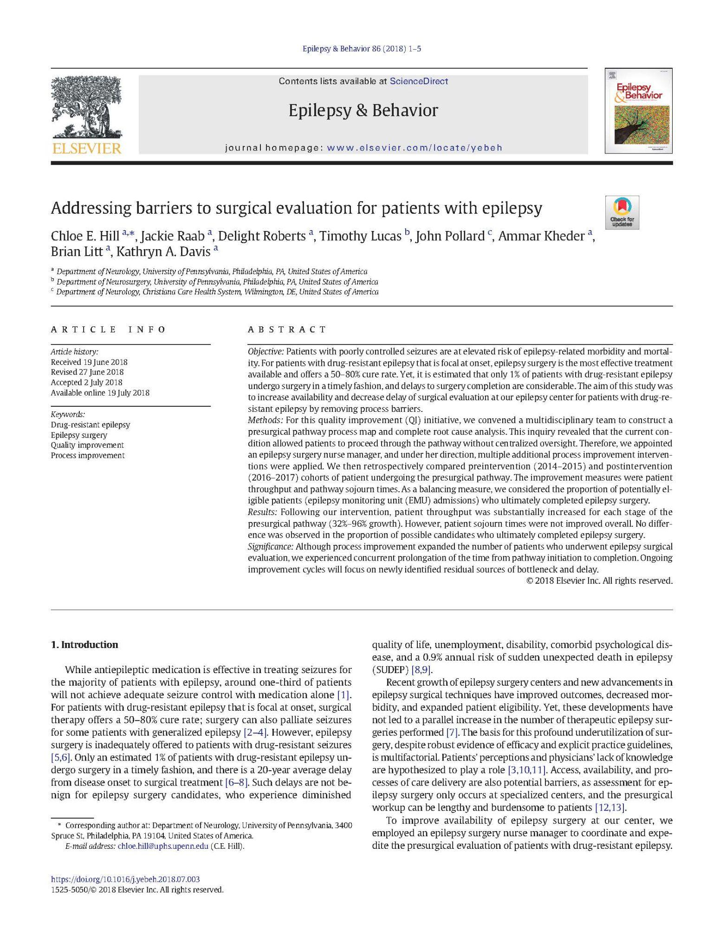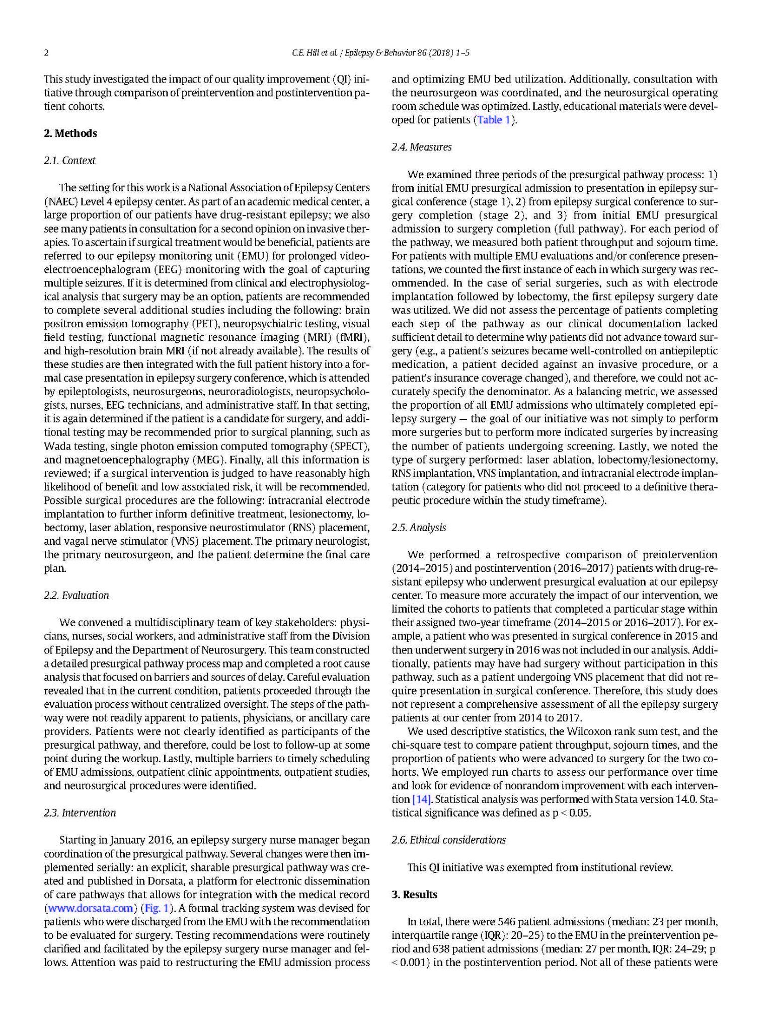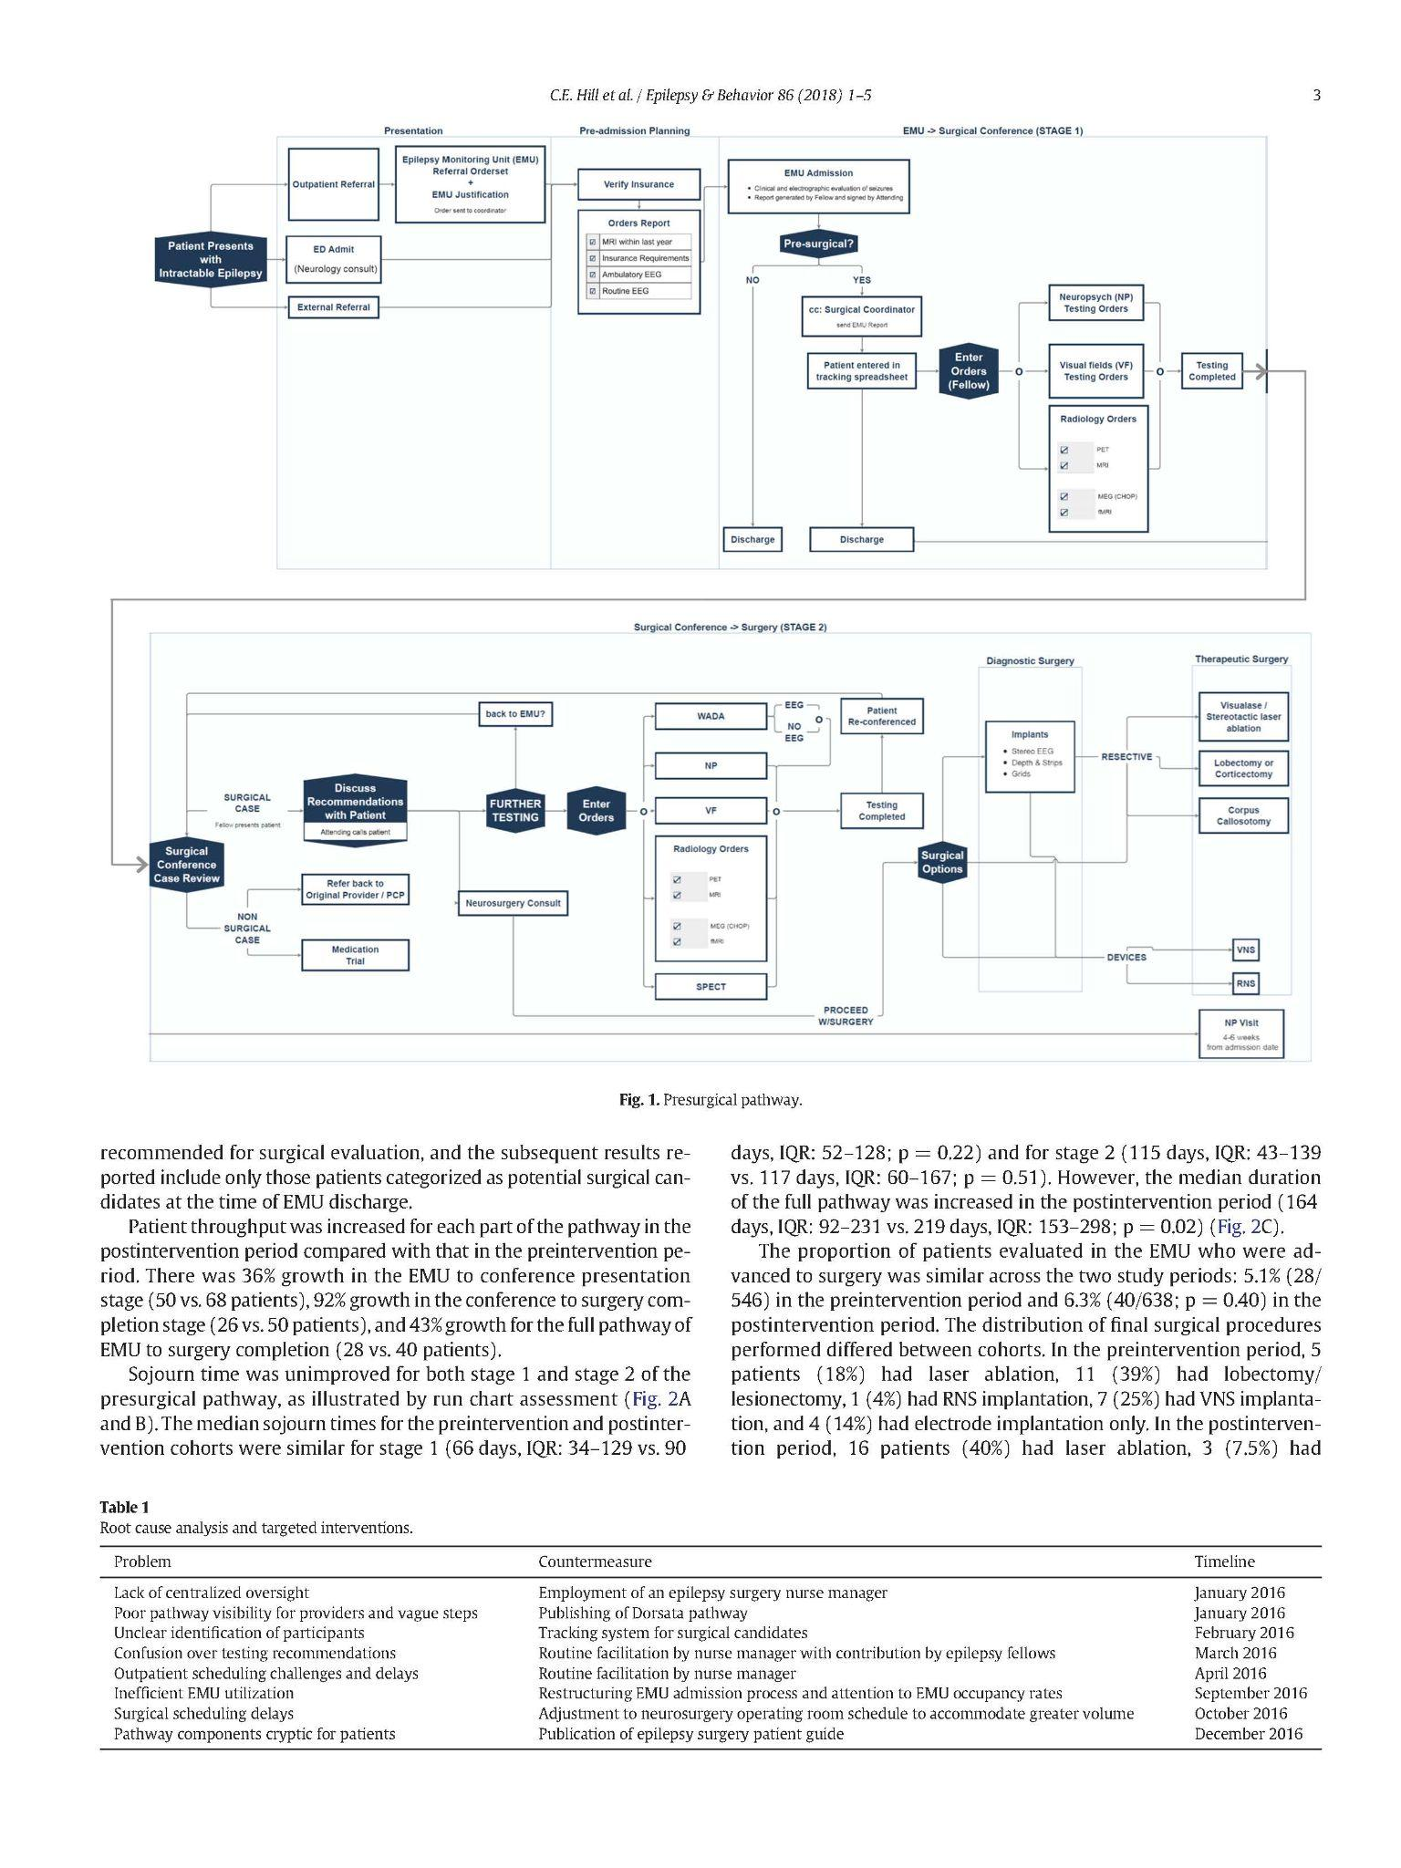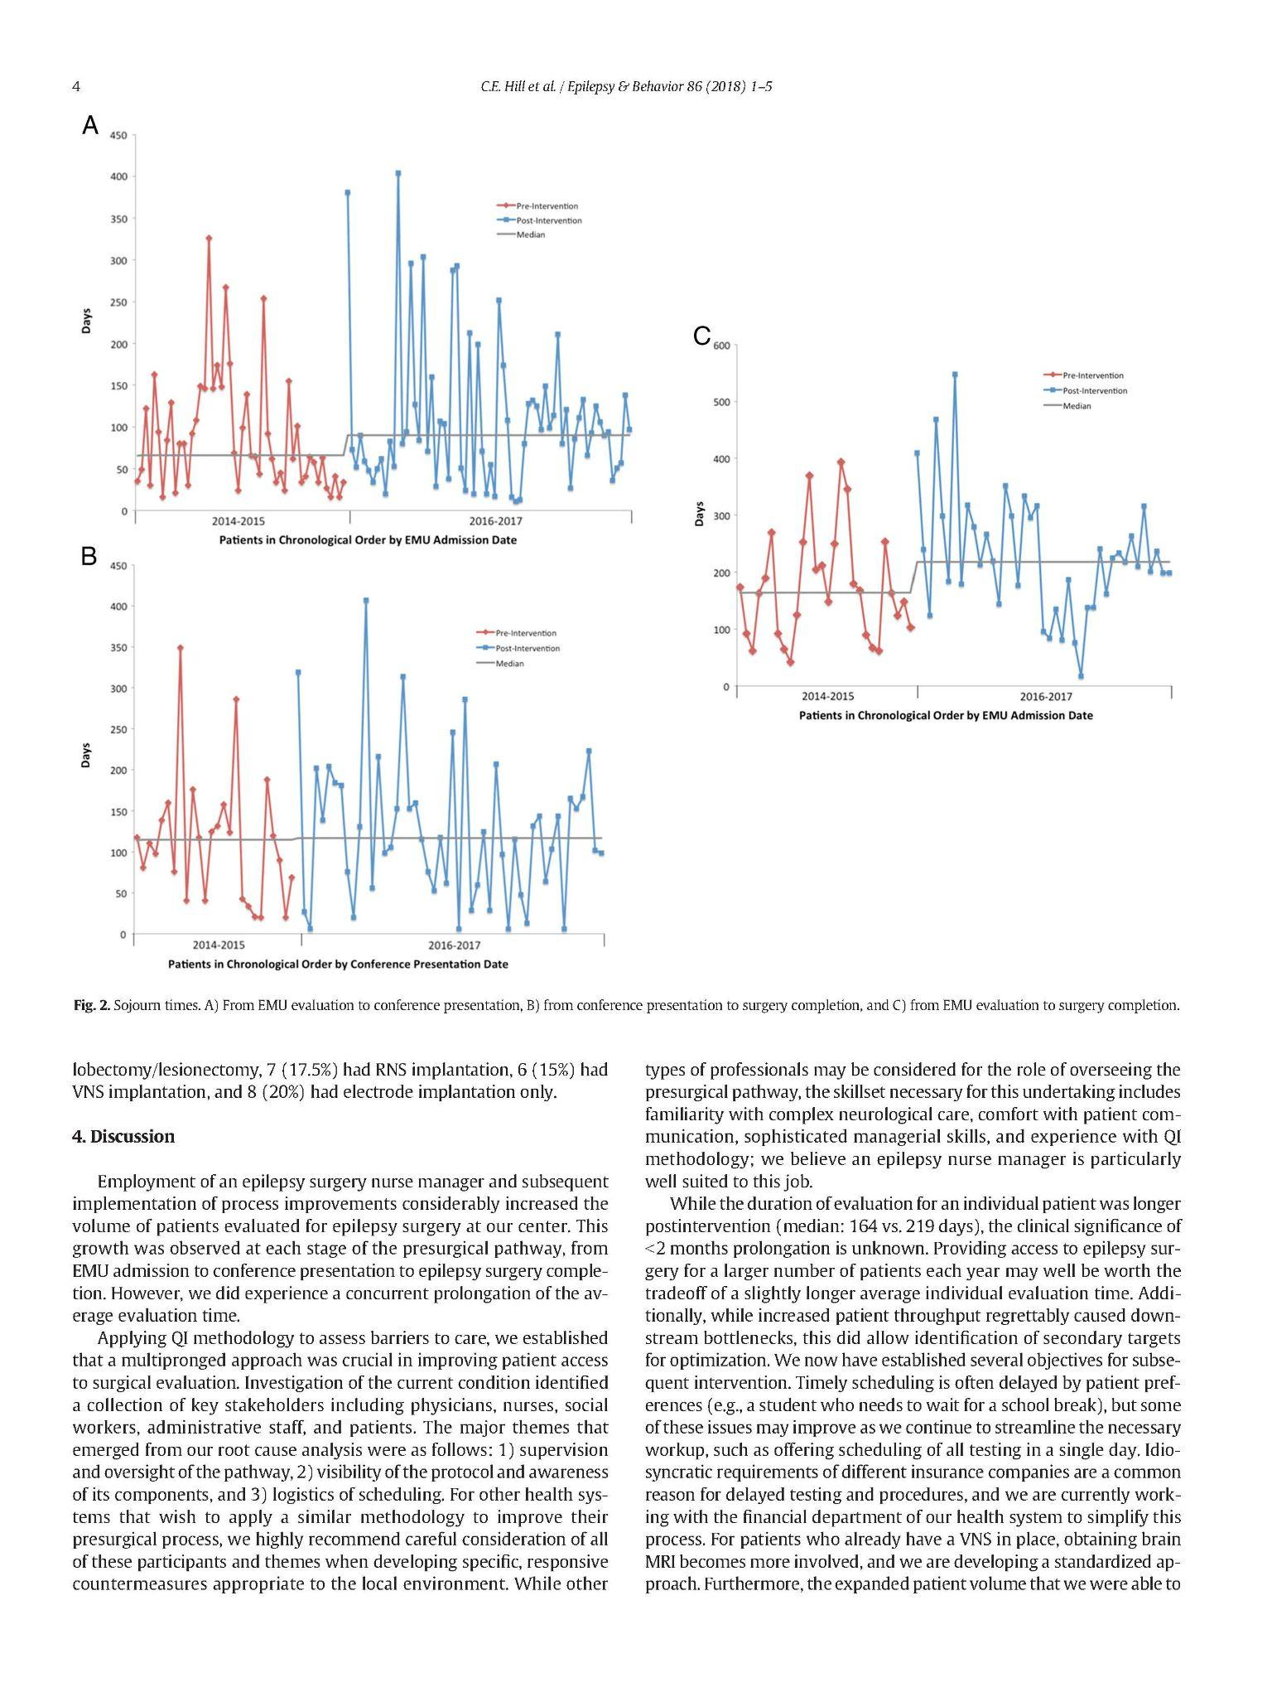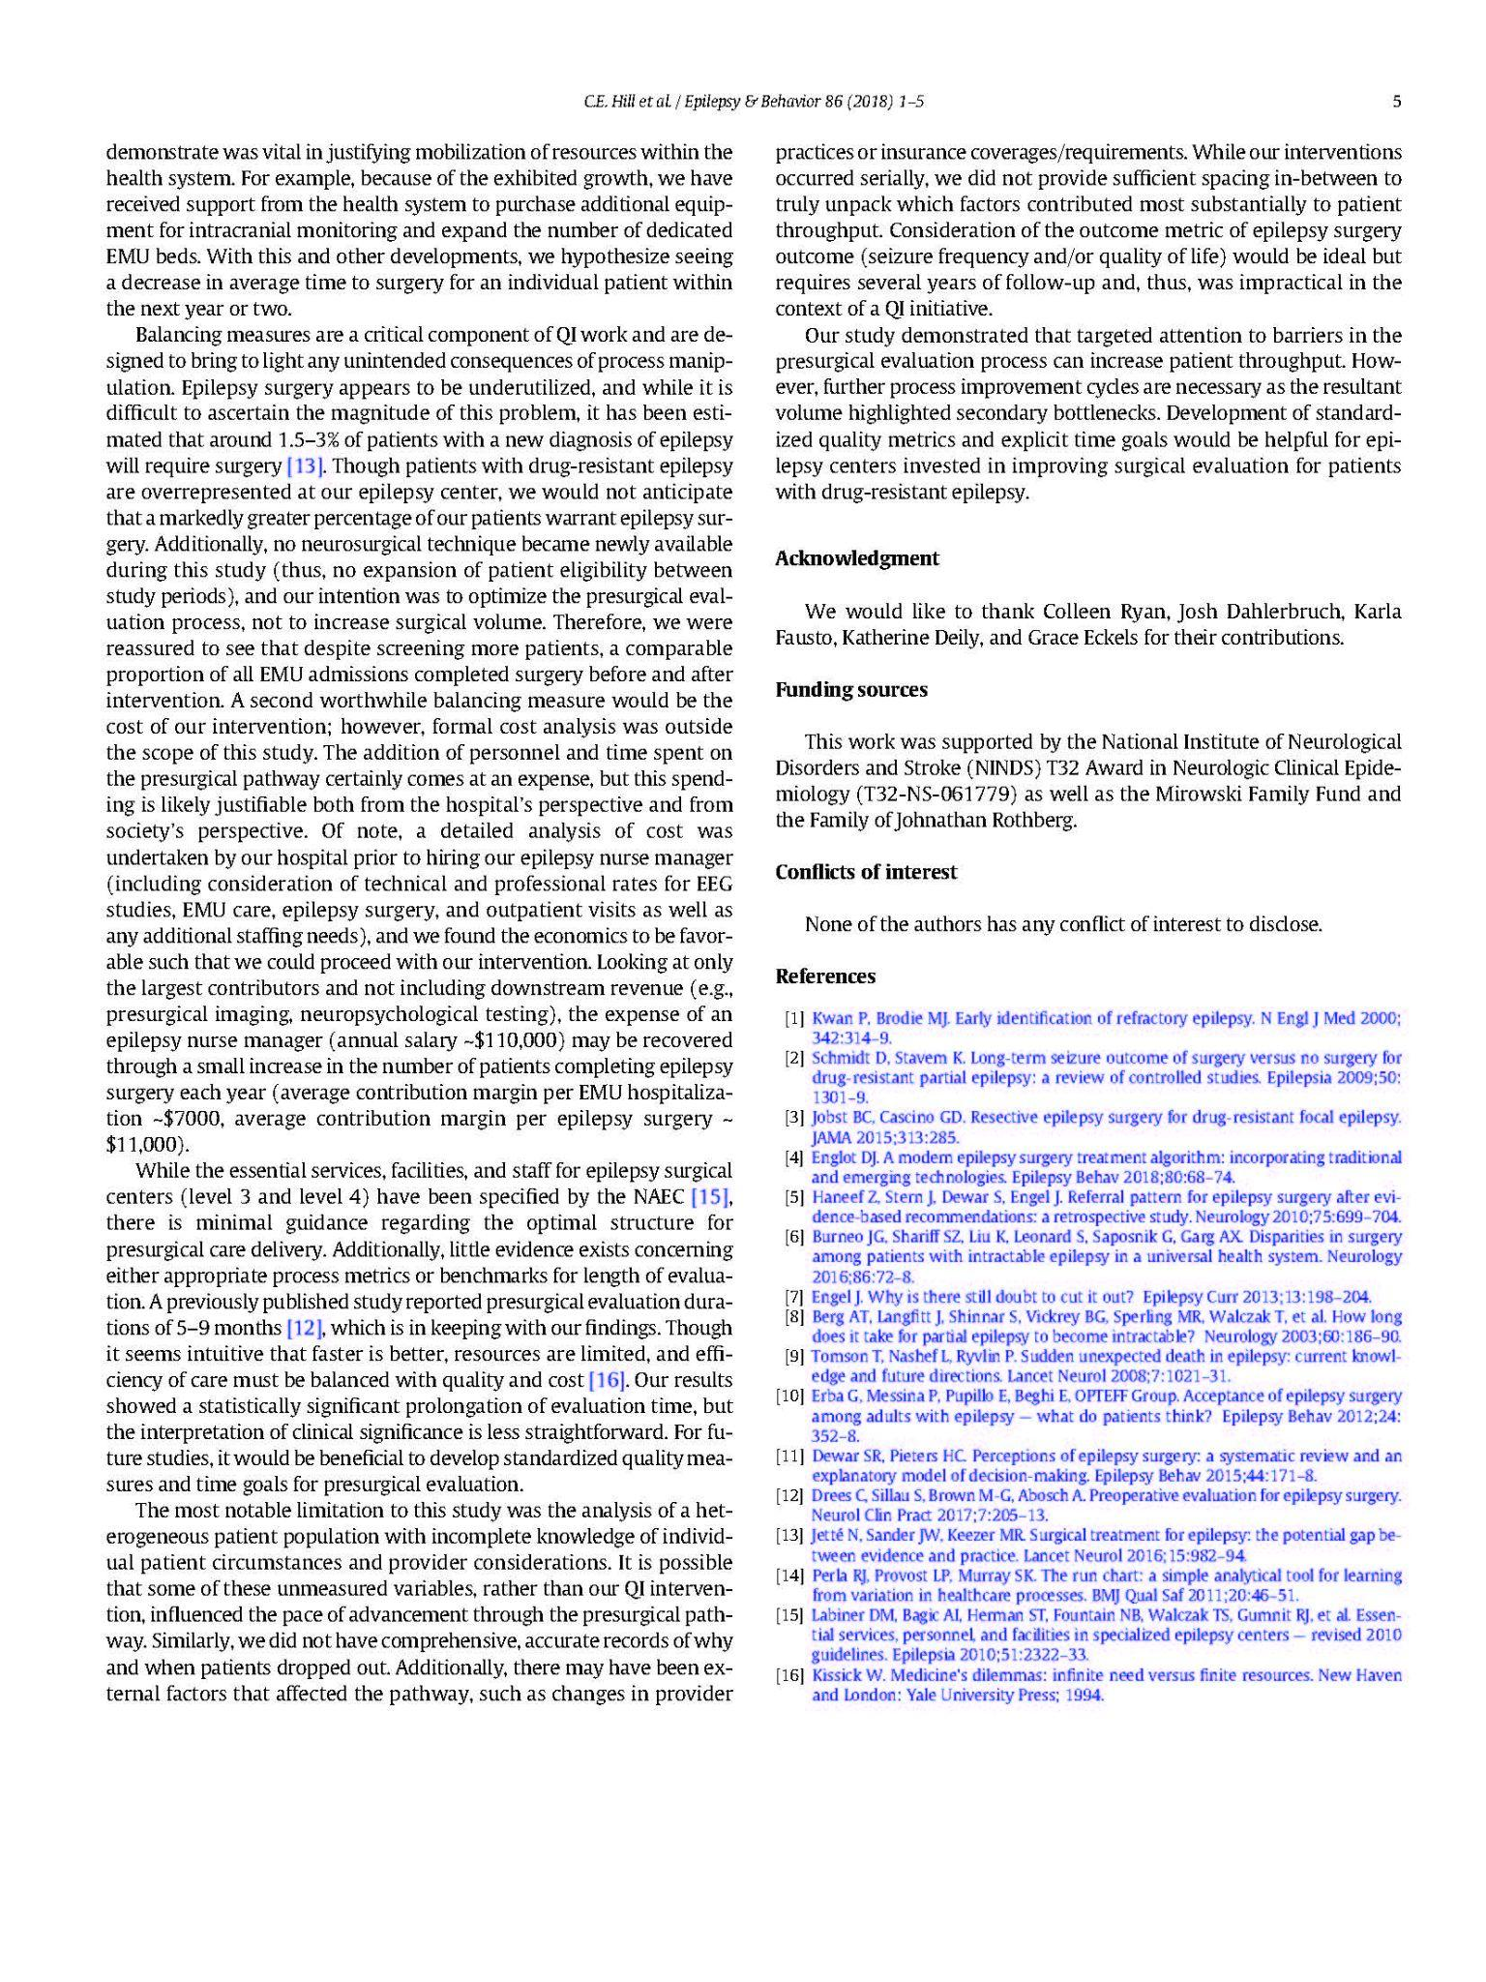

**Application of these research findings to this child**

*Summarize the article including the research study and findings.*

*How does this article relate to your patient?*

*How could you apply the research findings to the care of plan for your patient?*

This article talks about surgical therapy for patients with poorly controlled seizures and the reasons behind prolongation of the time from surgical intervention initiation to completion. They discuss while antiepileptic/anticonvulsant medication is effective in treating seizures in the majority of patients with epilepsy, around one-third of patients will not be able to manage it with medication alone. Surgery centers have opened with new advancements in epilepsy surgical techniques; however the development in surgical interventions are not able to be given to patients often due to several factors. Access, availability, process of care delivery as well as the assessment for epilepsy surgery and presurgical workup can be barriers. The paper concludes that employing an epilepsy surgery nurse manager and process improvements (discussed in paper) increased volume of patients evaluated for epilepsy surgery at the research center.   
This paper relates to my patient because my patient’s family has a few barriers that affect his care: insurance, language barriers and socioeconomic status. Not every single intervention will be available to them in order to provide proper care for the patient. Although his seizures are being properly managed right now, due to his skull lesion and the possibility of Langerhans Cell Histiocytosis, the future management of his focal seizures are not guaranteed nor predictable. I cannot directly apply the research findings to my patient, as the interventions and possible places for improvement are systemic or administrative.

***Part 9: Reference Page***

*Use APA format. List references and sources on a separate page called “references.” These are listed by author in alphabetical order. The first line of an entry is flush left and subsequent lines are indented ½”. Titles of sources are in sentence case (only the first word is capitalized). A minimum of 4 references are required.*

Hill, C. E., Raab, J., Roberts, D., Lucas, T., Pollard, J., Kheder, A., Litt, B., & Davis, K. A. (2018). Addressing barriers to

surgical evaluation for patients with epilepsy. Epilepsy & Behavior, 86, 1–5.

<https://doi.org/10.1016/j.yebeh.2018.07.003>

Keppra Side Effects. (n.d.). Drugs.Com. Retrieved October 18, 2021, from

<https://www.drugs.com/sfx/keppra-side-effects.html>

Lidocaine Side Effects. (n.d.). Drugs.Com. Retrieved October 18, 2021, from

<https://www.drugs.com/sfx/lidocaine-side-effects.html>

Oxcarbazepine Side Effects. (n.d.). Drugs.Com. Retrieved October 18, 2021, from

<https://www.drugs.com/sfx/oxcarbazepine-side-effects.html>

Partial (focal) seizure. (n.d.). Medline Plus. Retrieved October 18, 2021, from

<https://medlineplus.gov/ency/article/000697.html>

Potassium chloride Side Effects. (n.d.). Drugs.Com. Retrieved October 18, 2021, from

<https://www.drugs.com/sfx/potassium-chloride-side-effects.html>

UpToDate. (n.d.-a). Levetiracetam. Retrieved October 18, 2021, from

<https://www.uptodate.com/contents/levetiracetam-drug-information?search=keppra&source=search_result&select>

edTitle=1~95&usage_type=panel&kp_tab=drug_general&display_rank=1#UpToDate. (n.d.-b).

Lidocaine. Retrieved October 18, 2021, from

<https://www.uptodate.com/contents/lidocaine-local-and-regional-anesthetic-and-systemic-drug-information?search>

=lidocaine%20topical&selectedTitle=1~146&usage_type=panel&display_rank=1&kp_tab=drug_general&source=s

earch_result#F8768603UpToDate. (n.d.-c).

Oxcarbazepine. Retrieved October 18, 2021, from

<https://www.uptodate.com/contents/oxcarbazepine-drug-information?search=oxcarbazepine&source=search_resu>

lt&selectedTitle=1~105&usage_type=panel&kp_tab=drug_general&display_rank=1#F204825